PUGEAT Quentin

The impact of digital services
  - Literature review for EV02

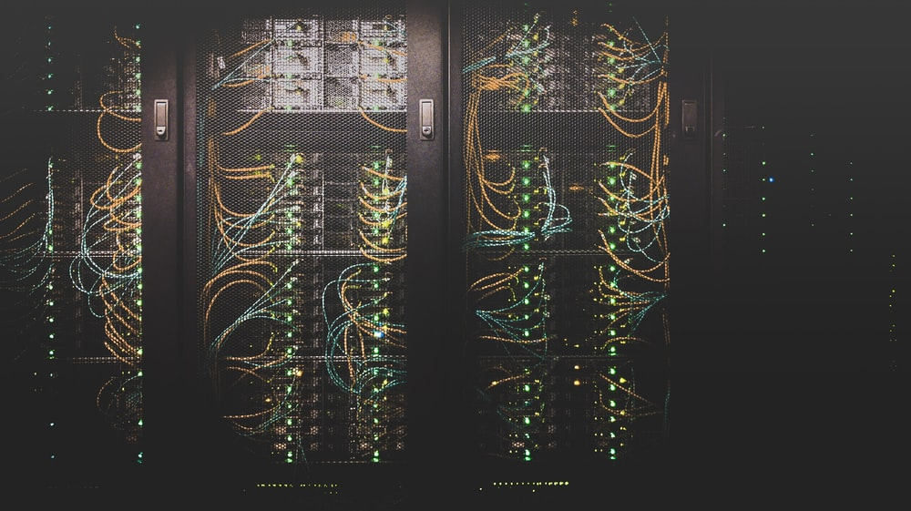
Photo by Taylor Vick – distributed under the Unsplash License
In a world where half the population uses at least one Internet-connected device, the question of the energy use and carbon footprint of digital services becomes more and more critical. A lot of studies exist on that matter, and while everyone agrees that there is work to do to lower the impact of Information and Communication Technologies, it is difficult to find clear information about this subject, between false comparisons, misleading claims, and varying values.

What is the ICT carbon footprint? Why is it hard to find that information?
Depending on the study you read, you will find that the greenhouse gas emissions of the ICT (Information and Communication Technologies) are between 730 million and 1 billion tonnes of CO2eq a year. That represents from 1.4% to 2% of the global emissions. These values increased every year until 2010 and then, surprisingly, stayed stable despite the rising number of deployed devices across the world (that includes user devices like phones and computers, but also professional and networking devices like servers or routers).
These values are greatly different because many studies exist for that subject but each one of them gives a different insight. Attention is required when searching such information as many reports and articles contain misleading comparisons. The most used one is the aviation sector. The CO2 emissions from that sector are 800 million tonnes. Therefore, we might think that ICT is as pollutant as aviation. Nina Lövehagen, from Ericsson Research, disagrees: “That number excludes the production of the fuel, the footprint of airplanes, the operation of airports and high-altitude effects. Moreover, it does not consider that the difference in number of users is huge. Approximately 70 percent of the global population use ICT, but it is estimated that only 10 percent of the global population use aviation services on a yearly basis.” ⁽¹⁾
It would be more interesting to calculate the emissions by user. The same report claims that a smartphone connected to the Internet would cause the same emissions as the fuel used per person for a transatlantic flight after 50 years of use. “Clearly it is a great thing to hold your international meetings online when you can”, says Lövehagen. ⁽¹⁾
Some other reports even show obviously disproportionate values. In 2019, a report from the think tank “The Shift Project” found that the use of video streaming (services like Netflix or YouTube) is responsible for more than 300 million tonnes of Co2, equivalent to the emissions of France. This report, after being covered by dozens of media outlets, was fact-checked: “For this to be true, video streaming (through Netflix alone) would have to consume 370 terawatt hours (TWh) of electricity per year, nearly double the electricity used by all data centres globally (205 TWh).”, says Colin Cunliff in an article for the ITIF. ⁽²⁾ ⁽⁸⁾ The electricity use of data centres was calculated by the IEA in 2017. ⁽⁷⁾

How are these values calculated?
To understand how ICT carbon footprint is calculated, we need to know is what ways it can impact the climate. On one hand, there are the direct emissions. These come from the manufacturing, the use and the disposal of hardware. On the other hand, there are indirect effects of our use of ICT coming from our behaviour. Indeed, changing our use of ICT can drastically change its impact, for the better or the worse. ⁽¹⁾
To calculate and understand carbon emissions from ICT, there are factors to consider:
- The energy mix. Needless to say, using electricity generated from renewables for our digital devices will create less impact than using electricity from coal. Knowing the energy mix used for powering devices is crucial to discover the weak links of the services we use. This was particularly discussed for Bitcoin, and many disagree about the carbon impact of the mining pools, because we cannot be sure about the number of pools and the type of electricity they use.
- The types of users. A heavy user, for example a gamer (typically using a powerful computer with a graphical process unit, several screens, and devices) will leave a footprint 7 times bigger than a smartphone-only user. ⁽¹⁾
- The location of the users. When we use an online service, our device will send data to a server, usually called a request. This request will have to get out of our local network through our router, then our Internet Service Provider will transfer that data to another network using one or several routers, and so on until our request is received by the server which is expected to give a response back to our device. The number of routers between us and the server is generally determined by the distance between us two: the closer the server, the less routers required, meaning less impact for every request and response transmitted between the user device and the server. ⁽⁶⁾
- The lifetime of devices. Between 30 and 50% of ICT’s carbon emissions come from user devices (that value varies from one study to another). This is explained by the fact that they have a very limited lifetime. Most smartphones are exchanged every two years, and computers every five or ten years. This is mostly explained by their fast obsolescence.

Expectations for the future
You would think that an increasing number of users for the Internet, implying an increasing number of deployed devices across the world would mean we could expect the impact of ICT to grow during the next decades. Once again, there is disagreement. Some studies say that emissions will stabilise because of saturation, others say that renewables will decarbonise ICT. ⁽⁵⁾
The first thing that can be said for sure is that energy efficiency is still improving in ICT. Hardware manufacturers continue to produce more powerful devices that require less energy to work. That has been especially the case for processors and microchips that allow laptops to run on battery for almost 12 hours nowadays. Older screens have been replaced by efficient LED screens over the last decade. This energy efficiency improvement can reduce ICT’s carbon footprint. If they stay the same, the emissions of data centres could stay at 1% of global emissions. However, this capacity of improvement might have a limit. Microchips being smaller and more powerful led to them overheating. To address that, manufacturers put a speed limit on them. If digital services demand grows, data centres will need more power as efficiency improvements will no longer counterbalance that demand.
It is expected than within a few years, everyone on Earth will possess a smartphone. The total number of deployed smartphones would then cease to increase. Unfortunately, innovation from tech companies will create new demands, it is already the case today with the Internet of Things (smart home appliance and smart speakers are trendy these days). This new demand will make the number of deployed devices across the world increase despite the smartphone saturation, making the carbon footprint from both the devices and the way we use it, increase.
A drastic change in users’ behaviour is expected as well. Many say that some parts of the carbon footprint of ICT, and especially online services, could be avoided. For example, unsubscribing from all the useless newsletters (and not simply deleting them once they arrived – the newsletter has already generated its footprint by being sent) could save 28.5kg of CO2eq according to the antispam app Cleanfox. ⁽²⁾

Conclusion
The impact of digital services and ICT in general is hard to determine, and a lot of disinformation and disagreement exists on that subject. Nonetheless, even in the best-case scenario, it has a significant impact, and while a simple change of some of our habits could decrease it, the most efforts must come from those who make ICT. The fast obsolescence of our devices and the energy mix used to run data centres are two of the key issues to treat in order to make ICT less polluting.

References
- Nina Lövehagen. What’s the real climate impact of digital technology? Ericsson Research Blog. February 10, 2020. Available at https://www.ericsson.com/en/blog/2020/2/climate-impact-of-digital-technology
- Sarah Griffiths. Why your internet habits are not as clean as you think. BBC Future. March 06, 2020. Available at: https://www.bbc.com/future/article/20200305-why-your-internet-habits-are-not-as-clean-as-you-think
- Colin Cunliff. Beyond the Energy Techlash: The Real Climate Impacts of Information Technology. Information Technology & Innovation Foundation. July 6, 2020. Available at: https://itif.org/publications/2020/07/06/beyond-energy-techlash-real-climate-impacts-information-technology
- Nic Carter. How Much Energy Does Bitcoin Actually Consume? Harvard Business Review. May 05, 2021. Available at https://hbr.org/2021/05/how-much-energy-does-bitcoin-actually-consume
- Charlotte Freitag, Mike Berners-Lee, Kelly Widdicks, Bran Knowles, Gordon Blair and Adrian Friday. The climate impact of ICT: A review of estimates, trends and regulations. Small World Consulting, Lancaster University. December 2020. 87 pages. Available at https://arxiv.org/ftp/arxiv/papers/2102/2102.02622.pdf
- D. Schien, C. Preist, M. Yearworth and P. Shabajee, "Impact of location on the energy footprint of digital media", 2012 IEEE International Symposium on Sustainable Systems and Technology (ISSST), 2012, pp. 1-6, doi: 10.1109/ISSST.2012.6228017. Available at https://ieeexplore.ieee.org/document/6228017
- Dave Turk and Laura Cozzi. Digitalization and Energy. International Energy Agency. 2017. Available at: https://www.iea.org/reports/digitalisation-and-energy
- George Kamiya. The carbon footprint of streaming video: fact-checking the headlines. International Energy Agency. December 11, 2020. Available at: https://www.iea.org/commentaries/the-carbon-footprint-of-streaming-video-fact-checking-the-headlines

